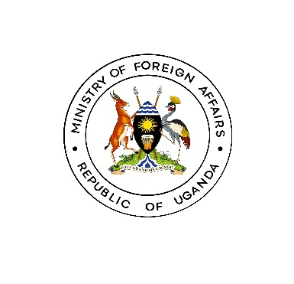

**MEDIA RELEASE**

*Kampala: June 11th 2024*

**Uganda hosts historic retreat with Uganda Heads of Missions stationed in the Ring States to boost economic ties**

The Ministry of Foreign Affairs has convened a landmark retreat with heads of Uganda Missions stationed in neighboring countries to enhance economic growth and development. The "Ring States", as they are referred to in the MoFA, include Rwanda, Tanzania, Kenya, DR Congo, Somalia, South Sudan and Burundi. The four-day event, themed "Enhanced Economic Growth and Development through Promotion of Economic and Commercial Diplomacy," aims to bolster Missions’ ability to attract regional economic cooperation and investments.

The retreat, which kicked off on June 11th at Serena Resort, Kigo, brings together government officials, private sector representatives, and experts to discuss strategies for improving economic and commercial diplomacy.

The discussions focus on various topics, including regional economic outlook, energy sector development, Uganda's trade performance with the ring states, and the role of the private sector in driving socio-economic growth. The retreat aims to increase Uganda's exports to regional countries, address non-tariff barriers to trade, and harmonize joint commissions and business forums for economic and commercial diplomacy.

According to Mr. Bagiire Vincent Waiswa, PS MOFA, the retreat provides a platform for addressing regional challenges and exploring opportunities for economic growth. He emphasized the importance of developing a resource mobilization strategy to access markets in the region.

John Mulimba, Minister of State for Regional Cooperation, Ministry of Foreign Affairs, highlighted the need to align Uganda's plans with the National Development Plan (NDP 4) and develop a clear strategy for economic and commercial diplomacy.

This historic gathering demonstrates Uganda's commitment to strengthening regional economic ties and promoting economic growth and development in the East African region. The retreat is expected to yield a draft action plan for economic and commercial diplomacy for FY 2024/2025 and a way forward for future retreats. **END**