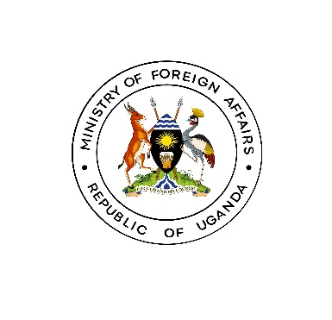

**MEDIA RELEASE**

*KAMPALA: 27th February, 2024*

**SWEDEN AND UGANDA TO STRENGTHEN ECONOMIC TIES**  
  
On February 27th 2024, H.E Maria Hakansson, Ambassador of Sweden to the Republic of Uganda, met with Minister of State for Foreign Affairs in charge of Regional Affairs, Hon. John Mulimba, at the Ministry Headquarters.

The meeting aimed to strengthen the bilateral relations between Uganda and Sweden and explore areas of mutual cooperation.

During the meeting, the two parties highlighted the importance of maintaining regular engagements to foster closer ties and enhance collaboration on various fronts including political, social and economic relations.

In this regard, Amb. Hakansson informed Hon. Mulimba that Sweden has signed an M.O.U with the Ministry of Energy and Mineral Development on cooperation in the Mineral Sector.

Both parties concluded with a commitment to further strengthen the existing ties between the two Countries. **END**